Application for the University of Lodz students in the Usosweb at the first stage of recruitment (Access path in the USOSweb: Student's Section, Student Exchange, Mobility offers or Applications)
- To participate in the recruitment process for part-time studies within the Erasmus+ programme you should submit an application in the USOSweb system indicating the mobility offers (universities) suitable for you and justifying your motivation for going to the selected universities.
- You can submit an application in the Applications or Mobility Offers tab after you have checked that the offer is available for you and included in the offers of your home faculty.
It is obligatory to read the information regarding part-time studies within the Erasmus+ programme at a given host university. You can find the link to the website on your own or in the details of the specific offer under Institutional homepage or Factsheet.
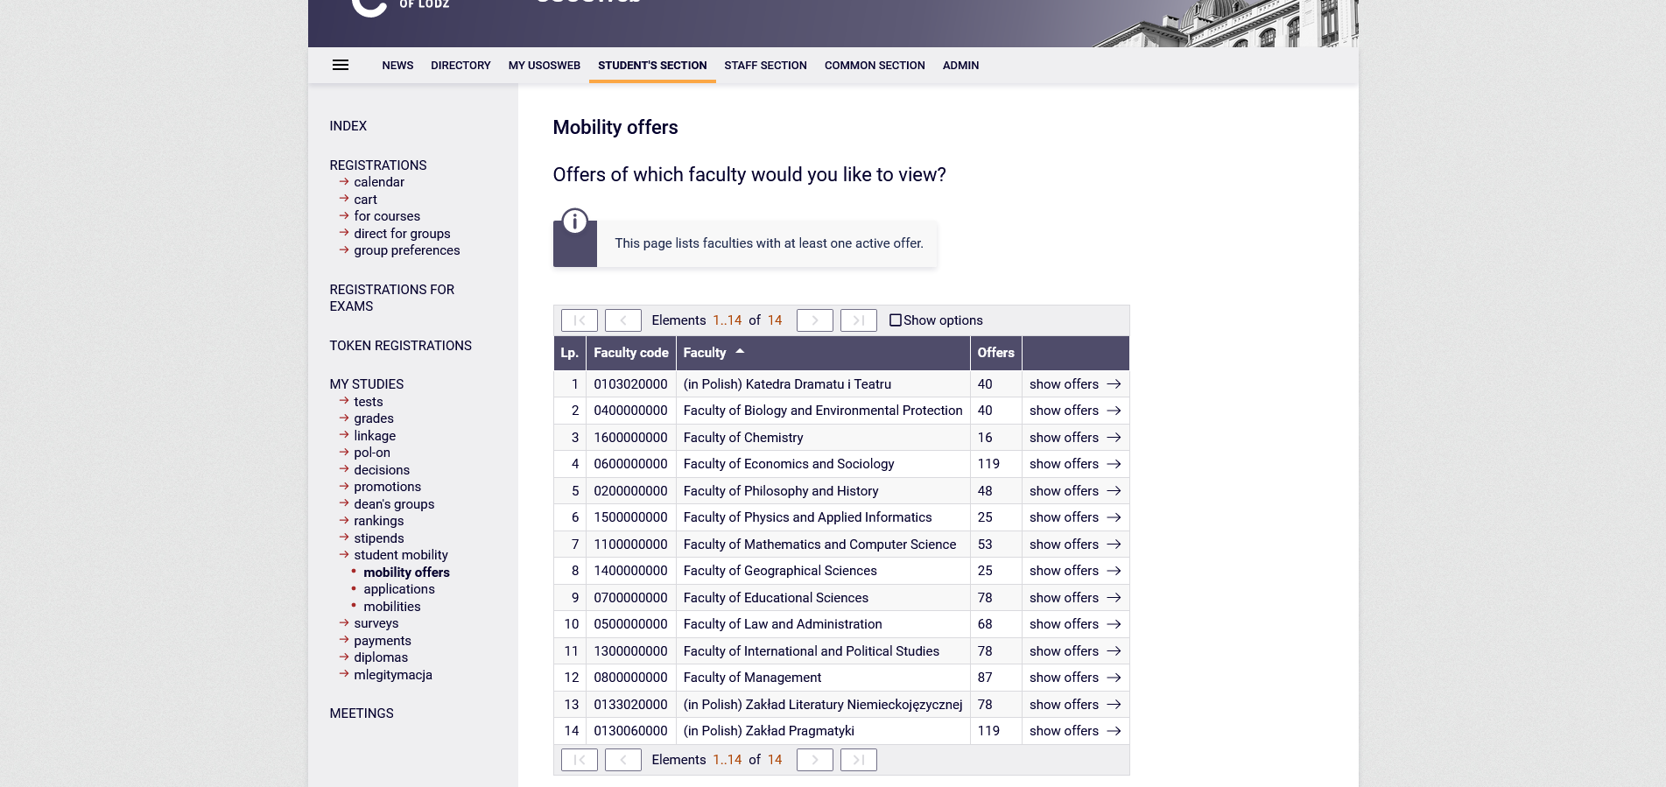
Screenshot 1. Faculties (units) in the USOSweb with mobility offers

- Students interested in going to a partner university for part-time studies due to their interest in women/gender studies may submit an additional application through the University of Lodz in USOS, regardless of their major or study programme at the UL.
- Students of the Faculty of Philology may apply in one of the three units in the USOSweb whose names are not related to the student's major but result from the faculty coordinator's affiliation with the unit.
- Students of Polish studies, library science, speech therapy, new media, theatre, journalism and cultural studies should search for mobility offers in the Department of Drama and Theatre.
- Students of English studies, business linguistics, romance studies, Italian or Spanish should search for mobility offers in the Department of Pragmatics.
- Students of Germanic studies, Polish-German studies, Russian, Slavic or Classical studies should search for mobility offers in the Department of German Literature.
- Students of the Faculty of Philology majoring in subjects different than those indicated above should search for offers in consultation with their faculty coordinators, as offers may be found in one or a number of the abovementioned units.
- Doctoral Schools participants may apply in the USOSweb through the faculty which offers courses compatible with their academic discipline.

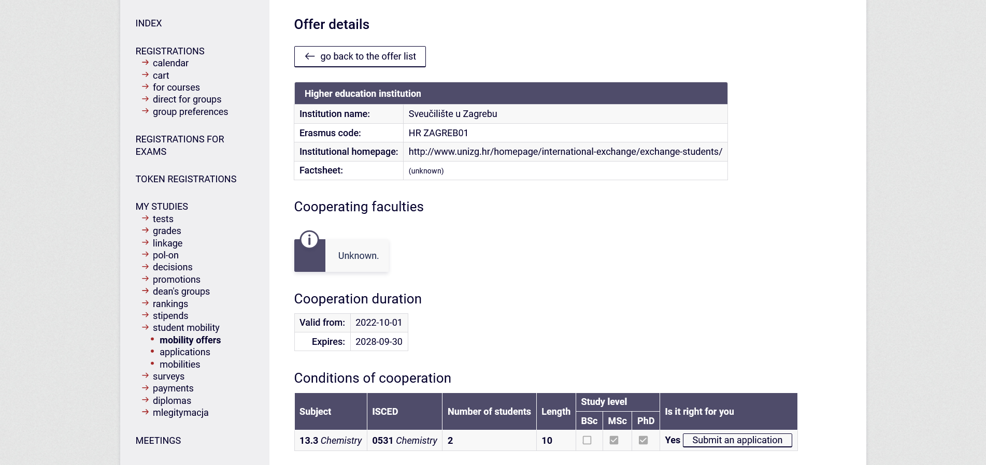
Screenshot 2. Mobility offer details
- If you start to fill in the application, it will be visible in the Applications tab. Until you submit it to the USOSweb, it can be edited during the first stage of recruitment.
- As you fill in the application, read the information and messages visible in the USOSweb carefully. If you have any doubts, use the prompts by clicking on .
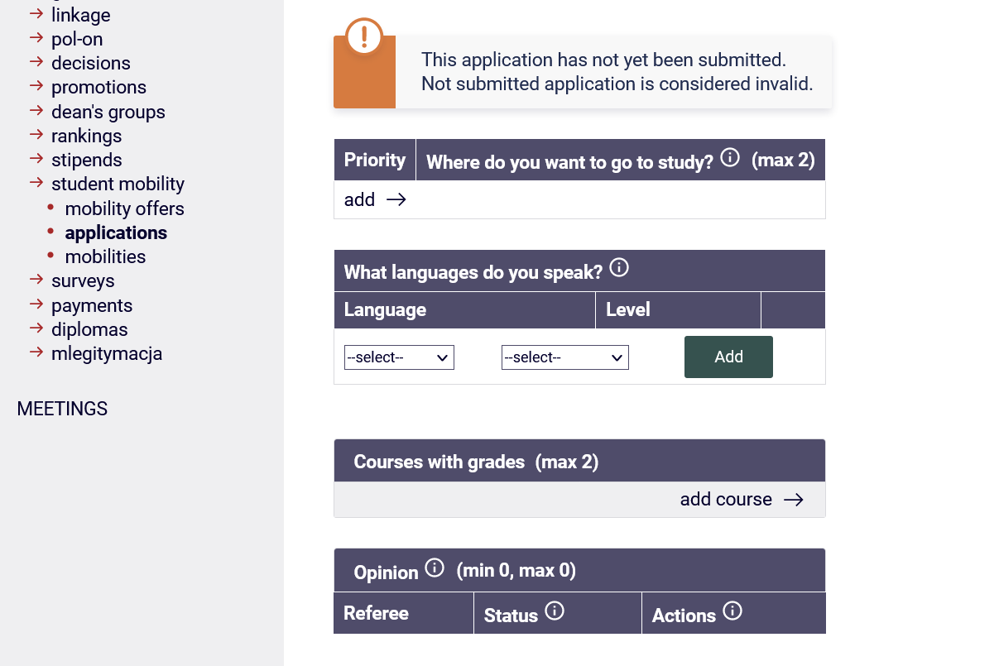
Screenshot 3. Application in the USOSweb
- You will not be able to upload a separate CV or cover letter file into the USOSweb application. You can type/paste the contents from another file (max 4000 characters) and then save each completed field.
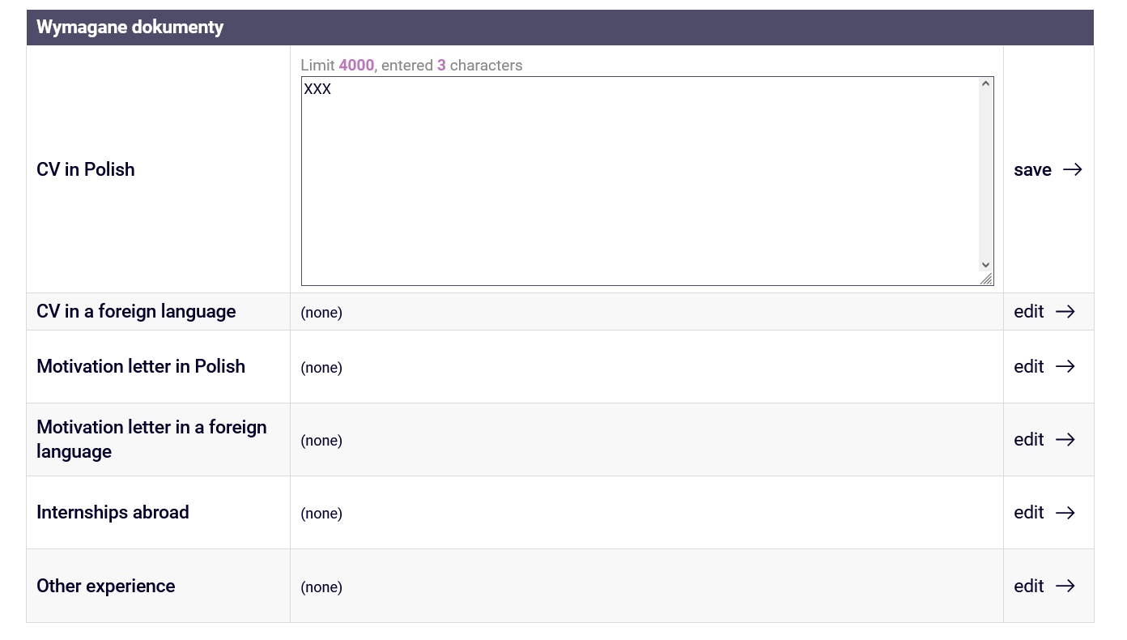
Screenshot 4. Application in the USOSweb
- If you want to apply in more than one unit, either because you are studying at two UL faculties or because you want to apply from your home faculty and are interested in women/gender studies, you can submit two applications and indicate the mobility offers available in the respective units. Students interested in women/gender studies can submit the second application through the University of Lodz in the USOSweb. If you are submitting more than 1 application, please inform the relevant faculty coordinator in the USOSweb and via email.
Remember that you can only be awarded one mobility in this recruitment even if you submit more than 1 application in the USOSweb.
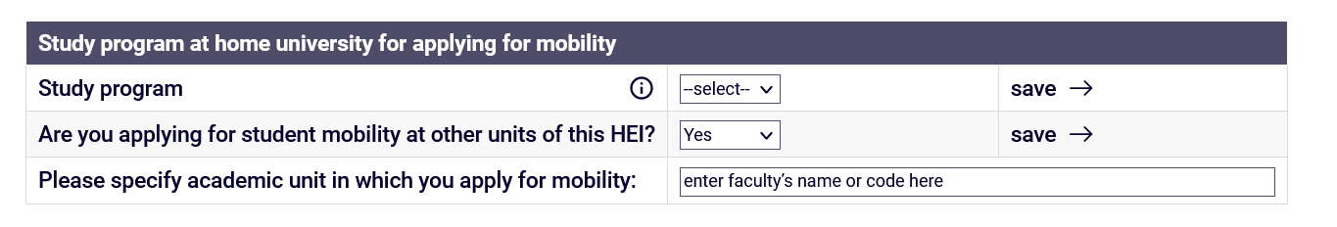
Screenshot 5. Application in the USOSweb
- If you have participated in a study/traineeship mobility in a physical or blended form, BIP – Blended Mobility Programme within the Erasmus+/LLP Erasmus, Erasmus Mundus from the UL or another university and the mobility has not been granted to you by the USOS system, you should declare your previous mobility in the USOSweb and save the completed declaration.
You can check if the previous mobility has not been granted to you in the USOSweb in the Mobilities tab.

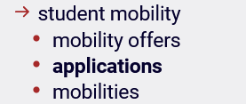
Screenshot. 5. Sub-tabs in the Student Exchange tab in the USOSweb
If you have not participated in any of the abovementioned mobilities, or you have but the mobility was granted via the USOSweb (and you have checked it in the mobilities tab), you do not have to declare any previous mobilities in the application. The previous mobility granted in USOS is already saved in the system and will appear in the application if your home faculty grants you the mobility in this recruitment. Further information is provided in the prompts in the USOSweb.
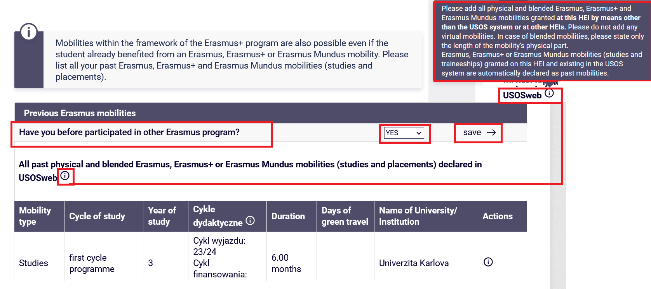
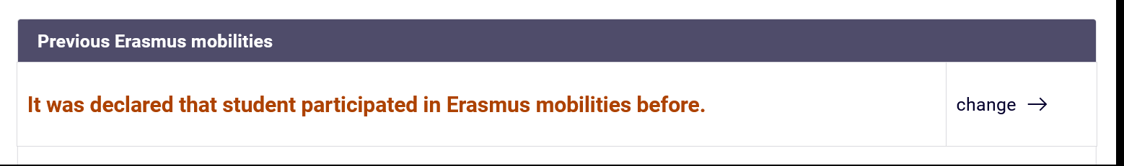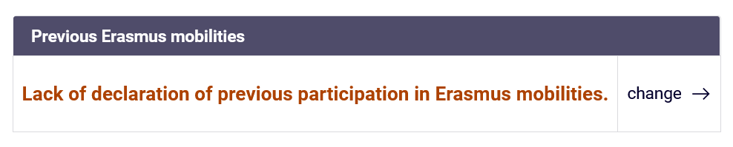
Screenshot 6. Application in the USOSweb on previous mobilities and possible status
- Once you have completed all the required fields and saved them, submit your application using the button below.
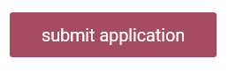
- If you have not filled in all the required fields or have not saved them, you will be informed that there is still missing information in your application.
Complete the missing data, save it and submit the application.
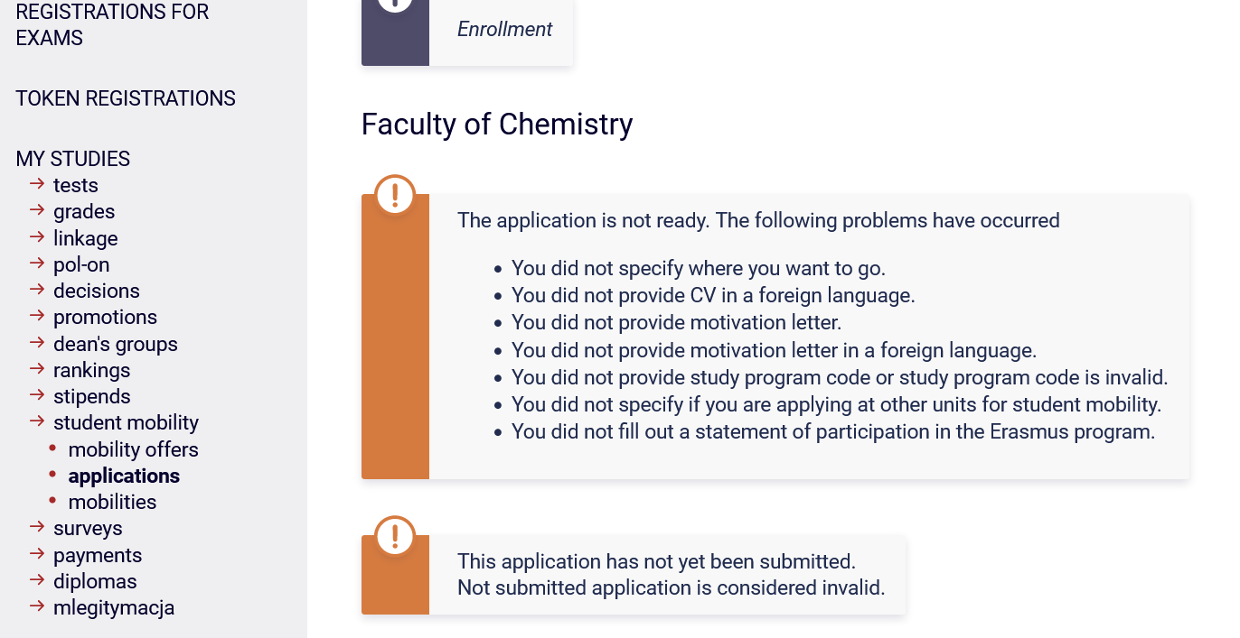
Screenshot 7. Message on missing data in the application and its status

- If you wish to apply for a part-time Erasmus+ mobility for studies, your application must have a ‘Submitted’ status, as shown in the screenshot below.
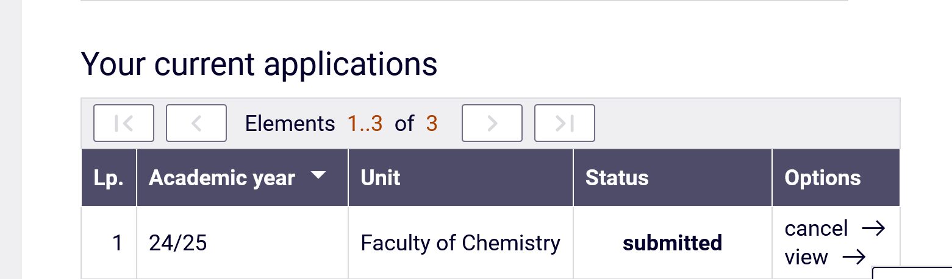
Screenshot 8. Submitted application and its current status

Only the submitted application will be assessed by the Faculty Commission and allows you to take part in the second stage of recruitment.
- Do not fill in the application on the last day of the first stage of recruitment.
- Check that your application has a ‘Submitted’ status preferably one day before the end of recruitment in the USOSweb (as in the example above). The deadline for submission is
1 March 2024 at 2:00 p.m., however, due to a large number of students applying in the last minutes of recruitment, do not leave this step until the very end so as not to derail your chances for part-time Erasmus+ mobility in the academic year 2024/25 (for winter semester, summer semester or full year).
- If you have any questions regarding the application or mobility offers, please contact the coordinator of your home faculty.
- Report any technical problems with the application to the faculty coordinator and the International Relations Office (gabriela.szkup@uni.lodz.pl) no later than 1 day before the end of recruitment. Send a screenshot of the Application showing the problem with your submission and describe the problem in an email.

